How to install the LAN CTE software from a BCM phone system

First of all, obtain the software which can be from browsing to the BCM using it’s IP address
Here is how to get it using the example screen shots below.
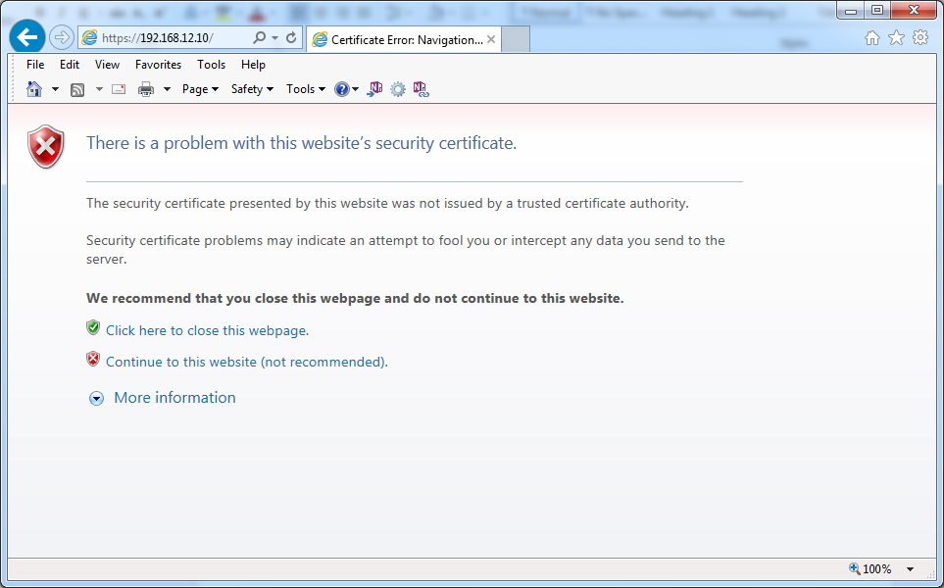
Press the “continue to this website (not recommended)” link.
You might get a Java problem as shown below
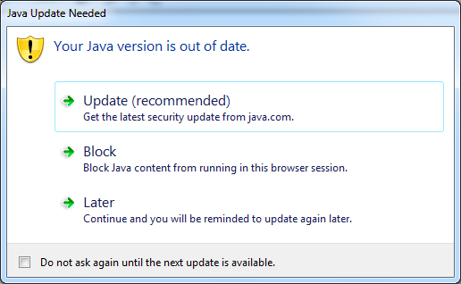

Press the “Later” link to see if you get access or the following message below.
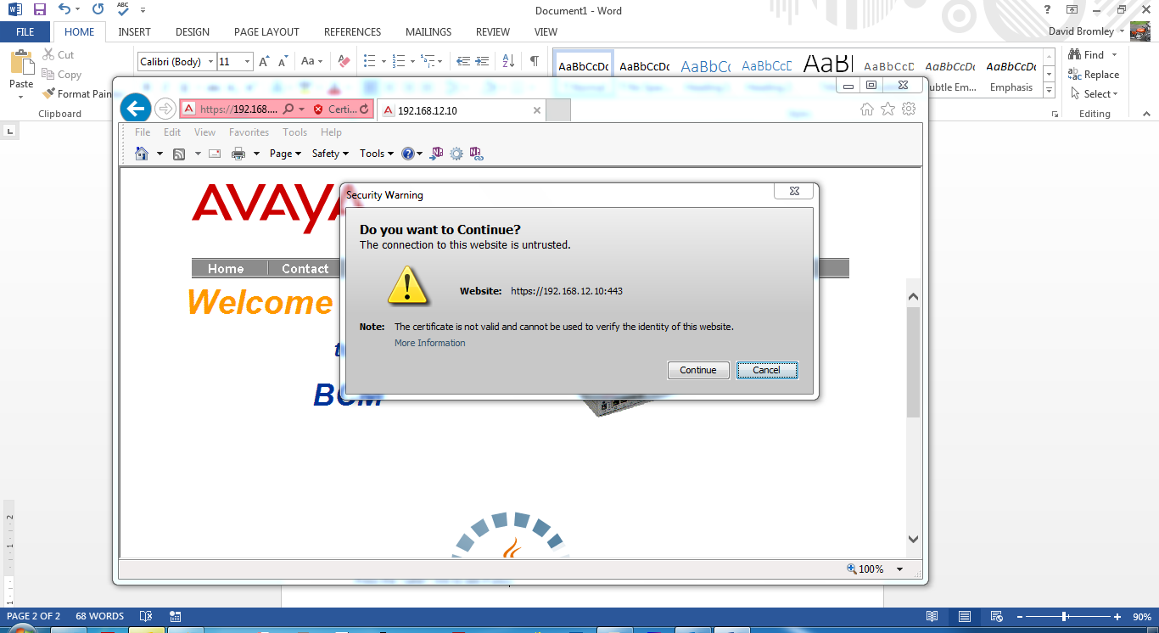
Press “Continue”. You might get another error message of..
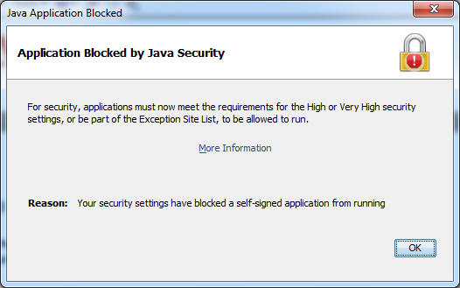
Press the OK box. Your screen might show this error below
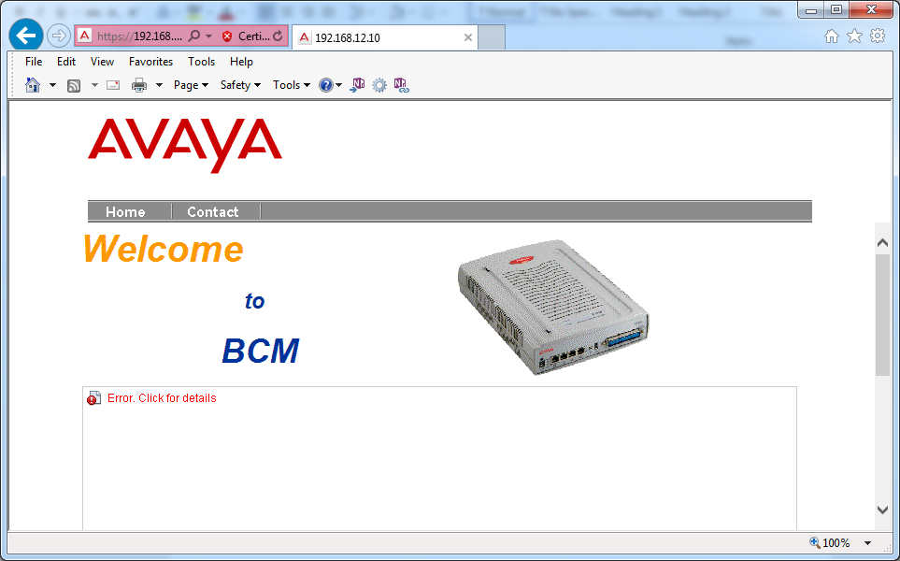
This means that the application is blocked.
You need to allow it by accessing your Java security settings as shown below
From the start menu, look for Java in “All Programs”. 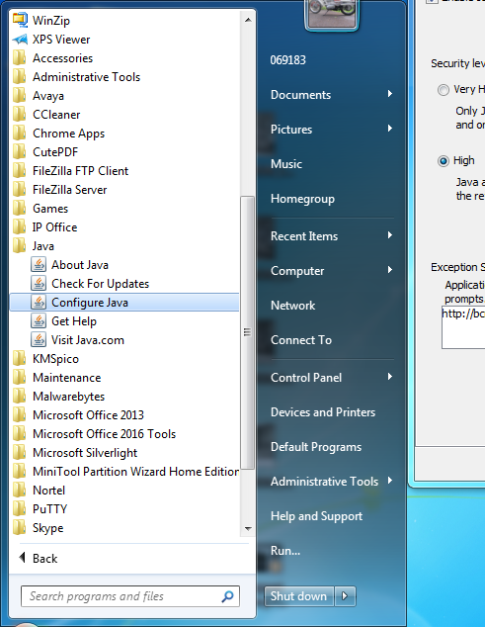
Then select the “Configure Java” link to get the following below.
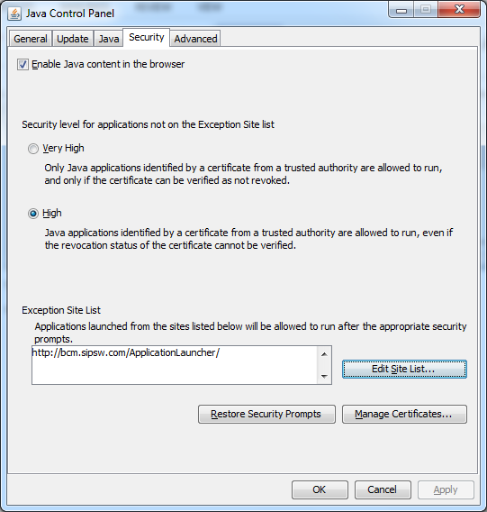
Make sure Java is set to “High” and then click on the “Edit Site List” button. You need to add in the BCM IP address details and press “Add” to store it.
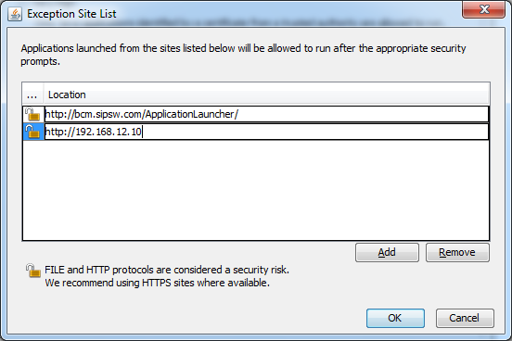
You will get the following message and press the “Continue” button.
. 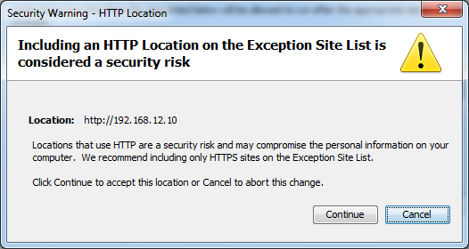
Press the “OK” button
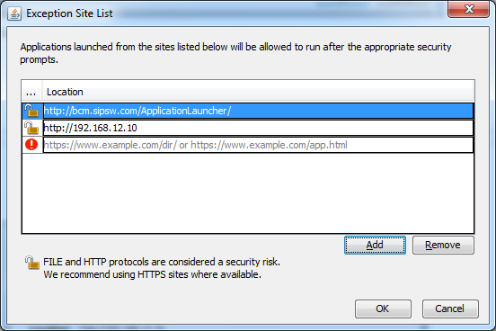
You should see your BCM IP address allowed in the exception list and press the “OK” button to complete the change.
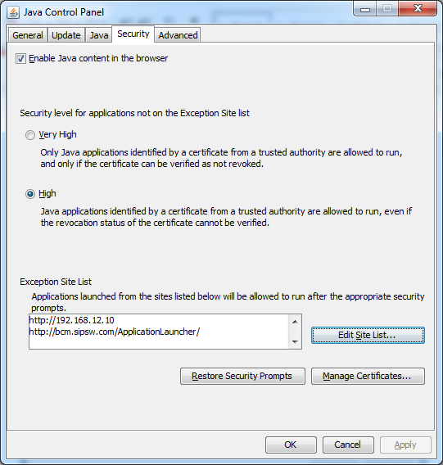
Using Internet Explorer or perhaps Firefox etc, Try to access the BCM via the browser again.
Press Continue if asked again to get back to the BCM page. You might still encounter the same error message of a blocked application. If that is the case, then go to the bottom of the page to press the link for “Click for Non Java enabled browsers”
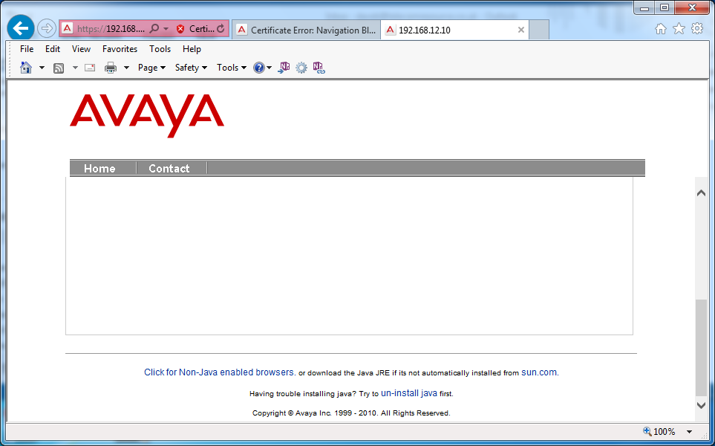
This time, you should get to the main screen of..
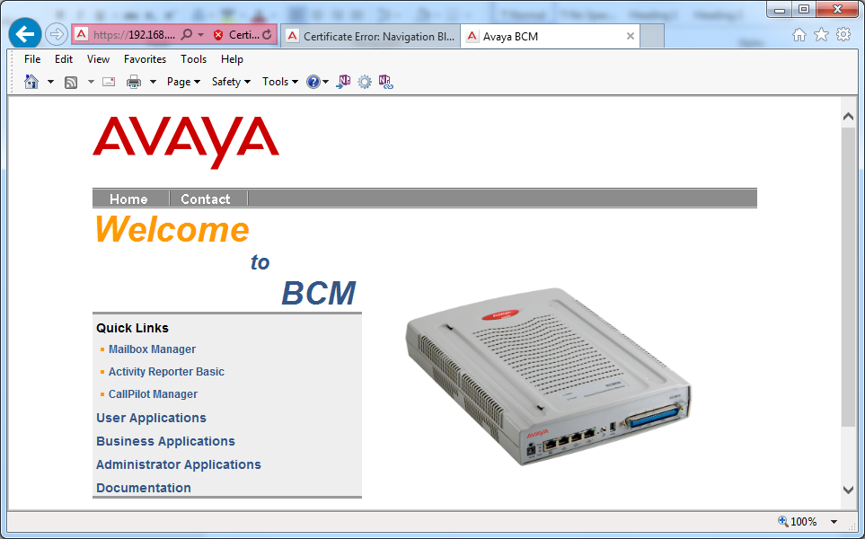
Click on the User Applications tab.
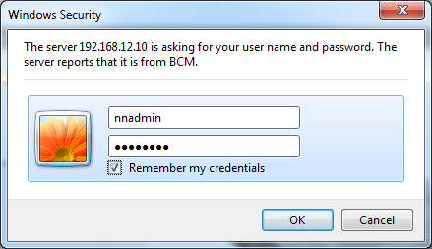
Enter in the BCM Account & Password details. The default password for nnadmin is PlsChgMe!
If successful, then you will get the User Applications as shown below.
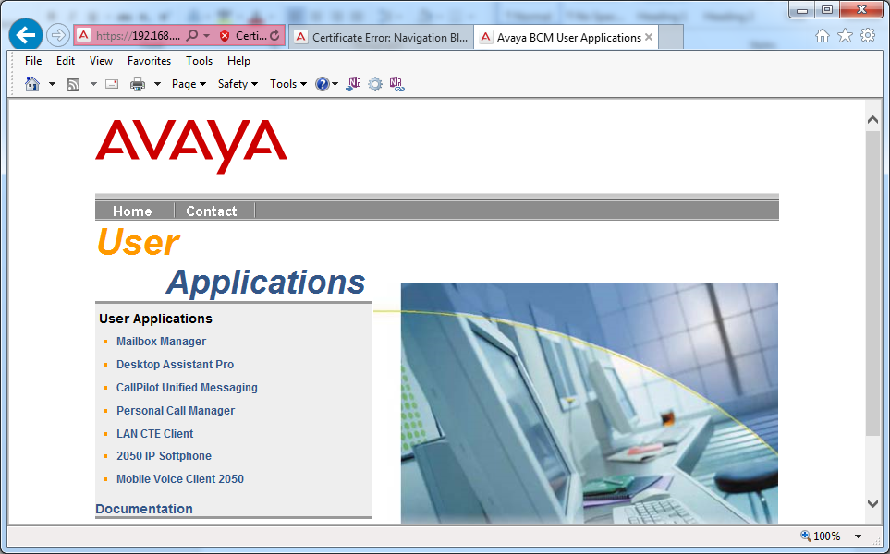
Click on the LAN CTE Client link
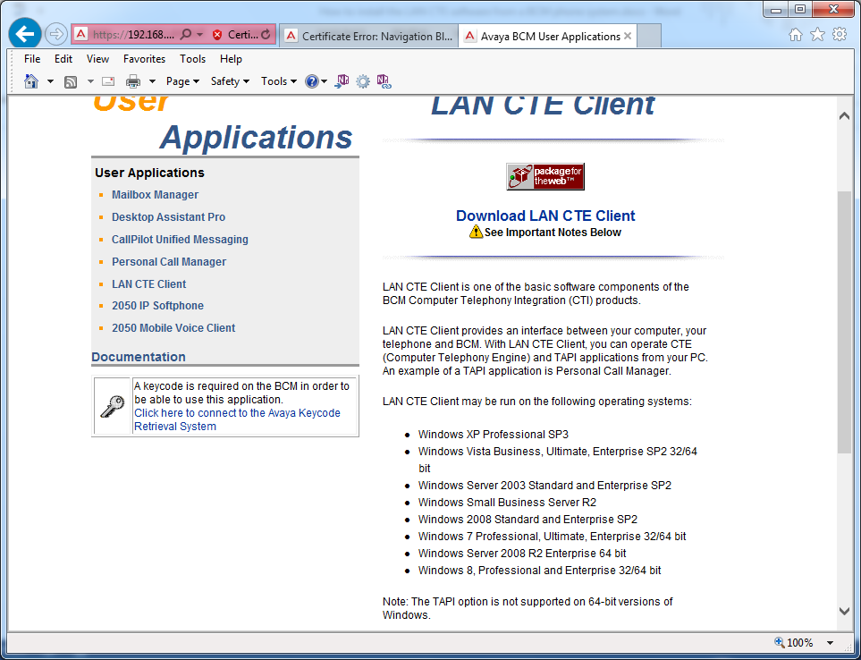
This explains what is does and what it is supported on. Remember that 64 bit computers won’t work
Click the “Download LAN CTE Client! Link to save the file.
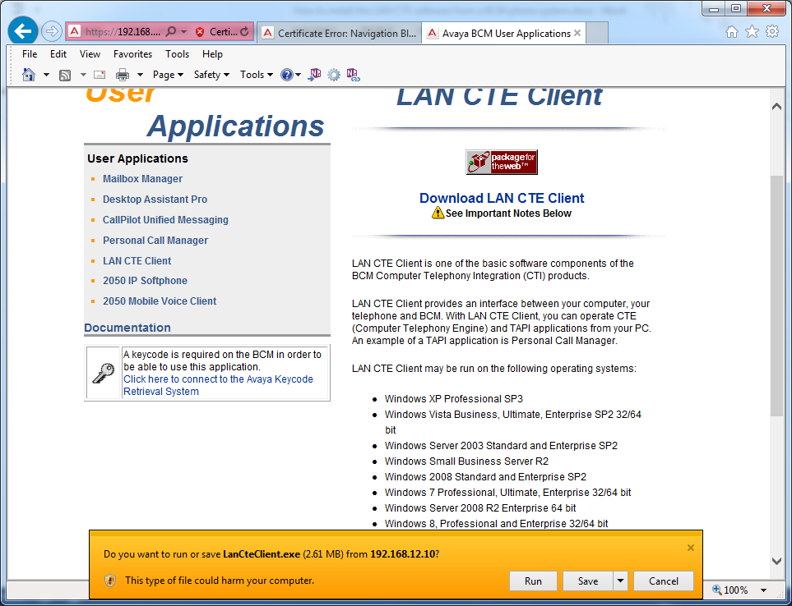
Save the file somewhere such as your desktop. Close down your browser.

Go to where you saved your file and double click it to run it.
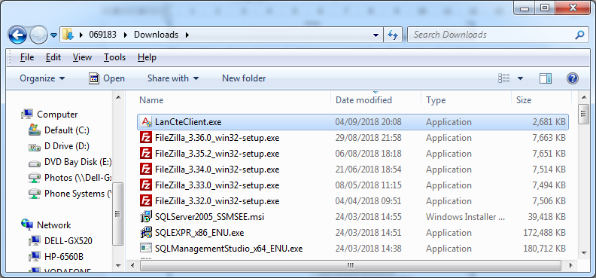
It should start installing as..
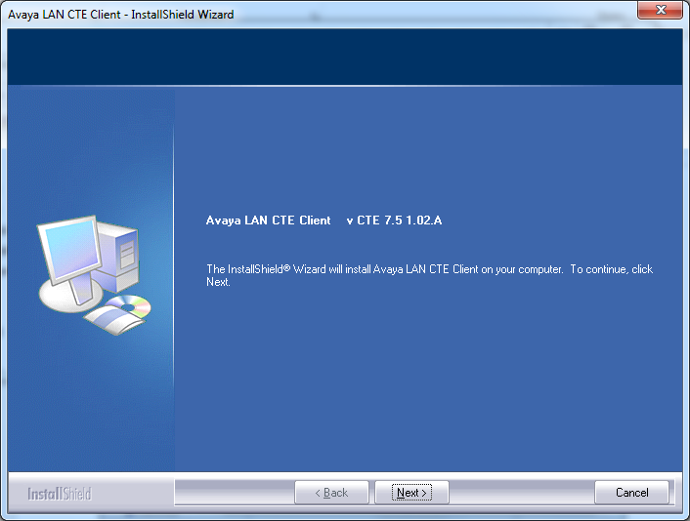
Click the “Next” tab and accept the agreement
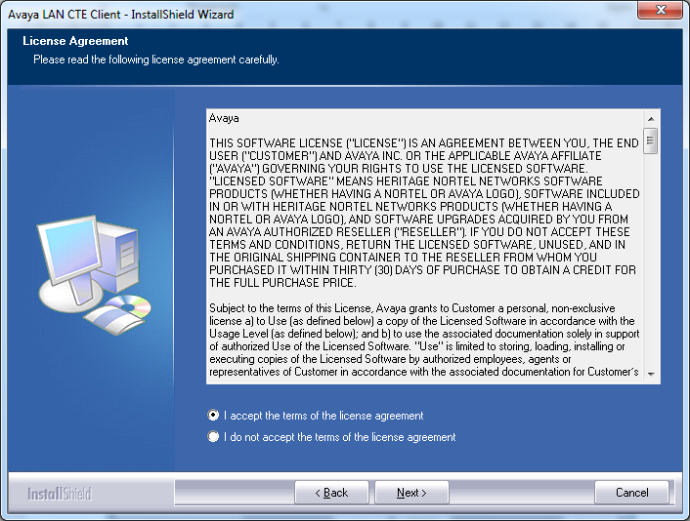
Press the Next tab again.
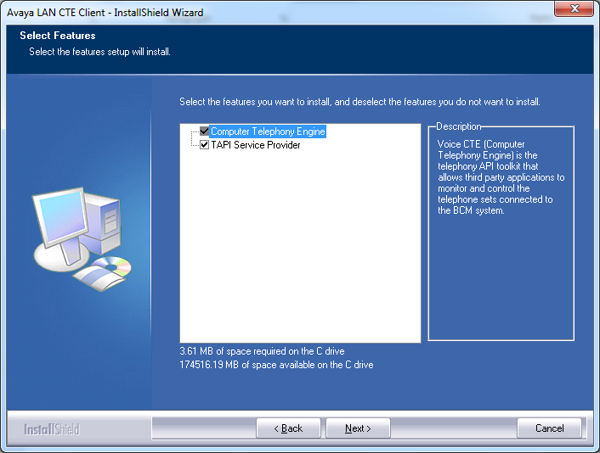
Press the “Next” tab
At this screen below, enter in the IP address of the BCM phone system before you press the “Next” tab
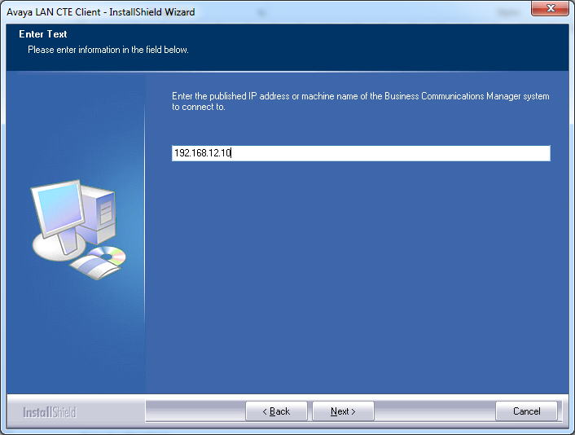
You get a summary message below showing what was entered in. Press the “Next” tab
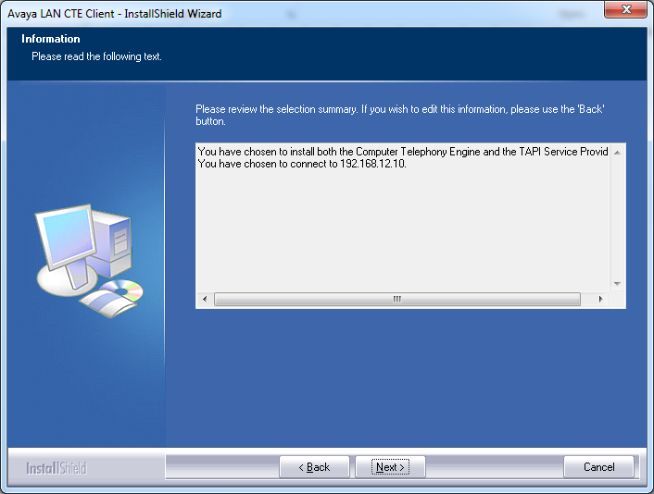
Now press the “Install” tab
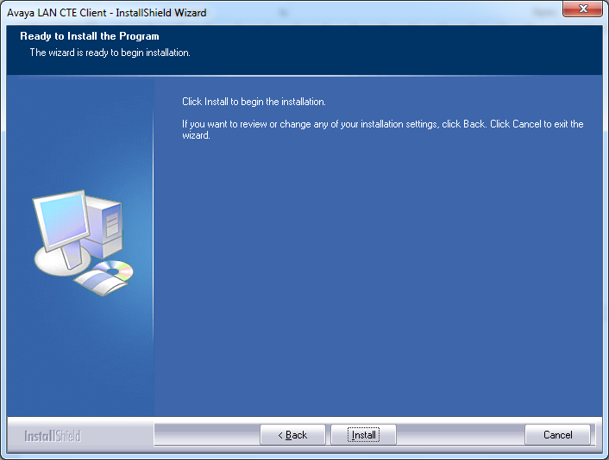
Just press the “Finish” tab to close the installation screen.
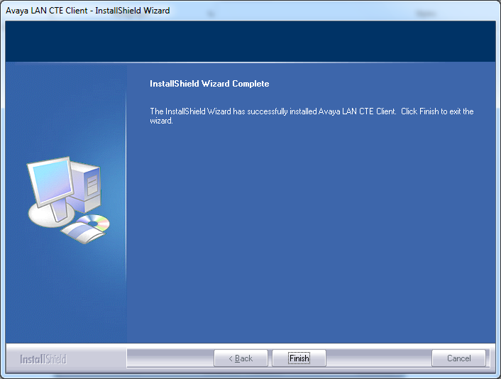
Checking the LAN CTE application
Take a look on your computer on the desktop bottom right hand side in the icon area. There should be a new icon that looks like a space shuttle on its launch pad. It is called the BCM TSP Launcher.
Right click on the icon to select the BCM TSP Control Panel as shown below
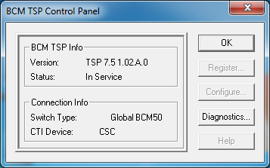
The details above indicate that the BCM TSP is connected to the BCM phone system.
Setting up the BCM Element Manager
Log into the BCM Element Manager Application and navigate to where you input the LAN CTE computer details. In the example below, there is one client registered with IP 192.168.12.7
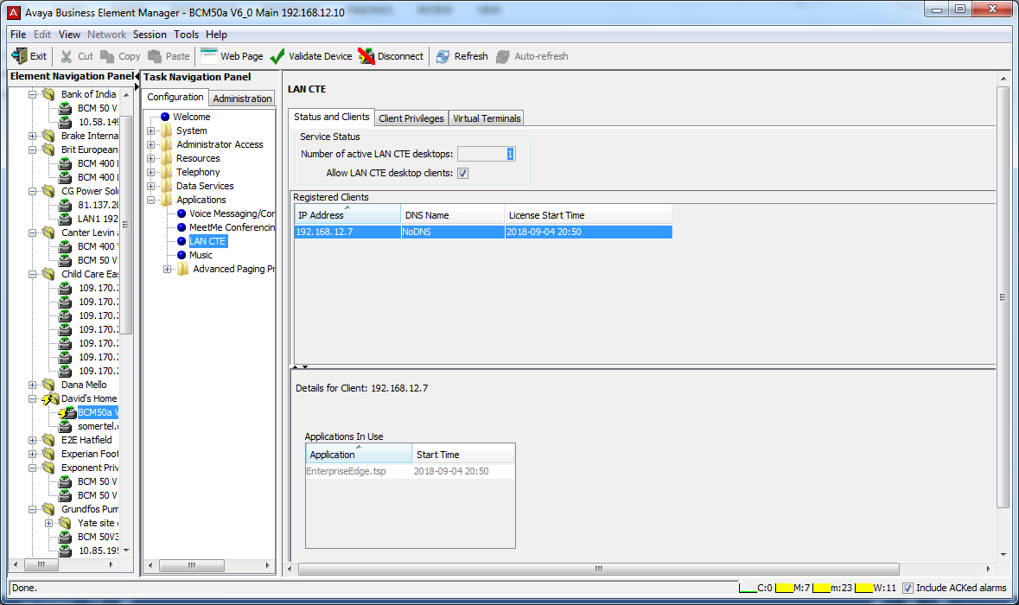

On the computer that had the LAN CTE software installed, find the IP address by pressing the “Start” button and entering CMD in the search box.
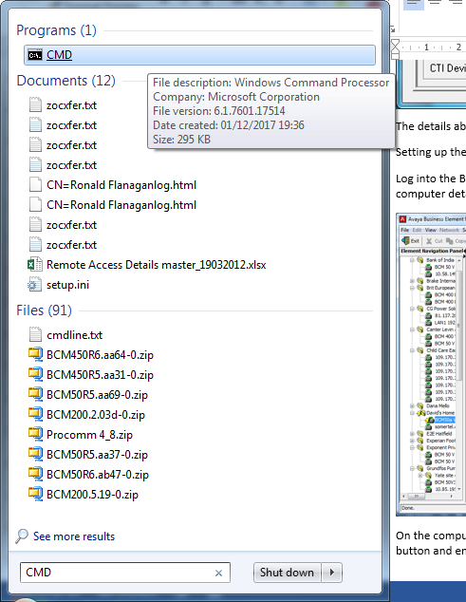
Click on the CMD to open up the Microsoft DOS application. Key in IPCONFIG and press enter.
The IP4 address details should be the same as found in the BCM Element Manager Application
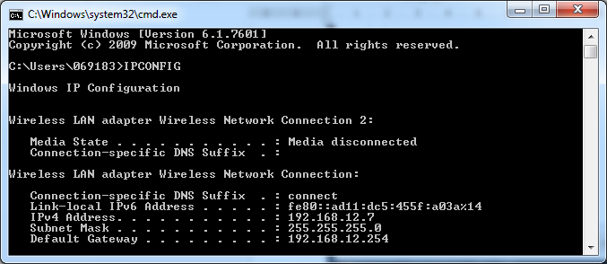
Whilst still in the DOS tool, enter in IPCONFIG /ALL to get the computers Host Name
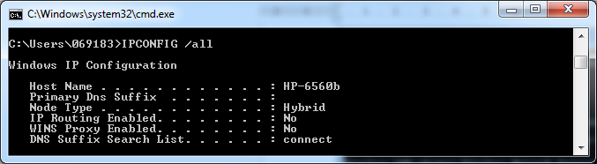
Another way is to go to Control Panel and look under System as shown below.
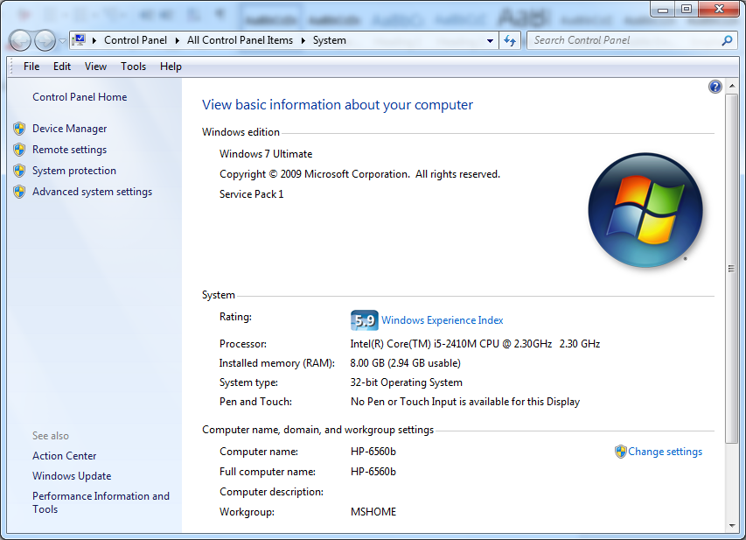
The next stage is to add the computer onto the BCM and this is done by adding it in as shown below using the “Add” tab in the Element Manager Application to get a box showing 3 ways of identifying the computer. Usually the Machine Name will be needed as IP addresses can change.
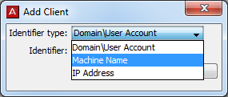
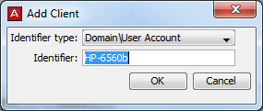
Click the “OK” tab to accept the changes.
You should see the new entry as the example shown bellow
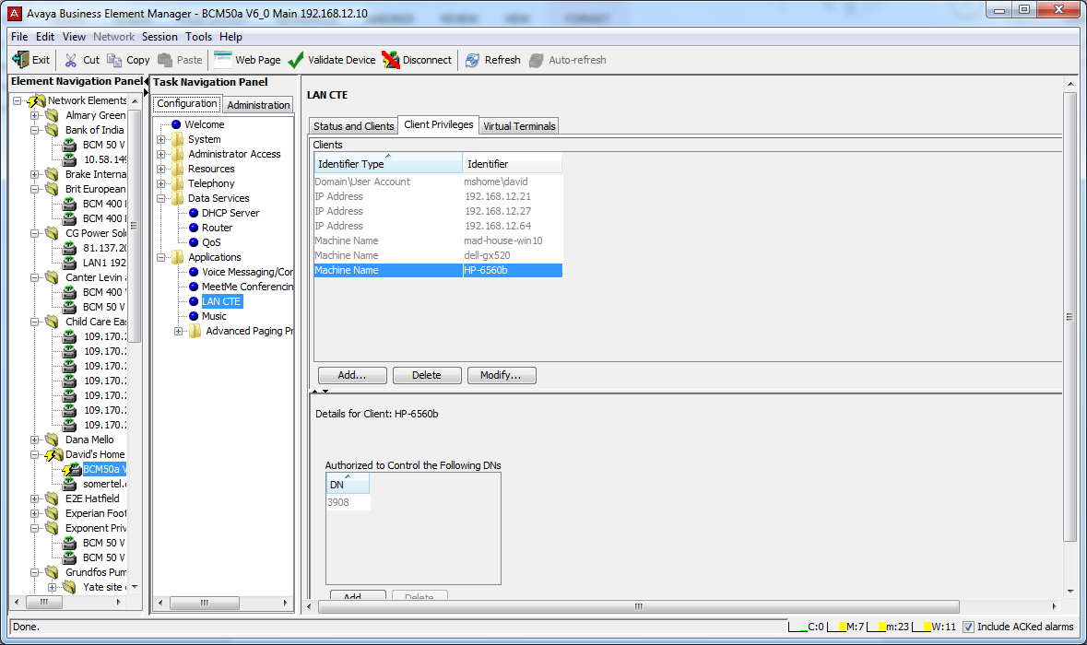
On the bottom part of the screen is where you can add in your extension number. I used extension 3908. Press the “Add” tab.
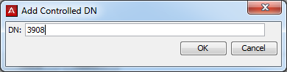
Press the “OK” to add the extension number in.
You should now have your LAN CTE configured.

